Lake Wisconsin Alliance Sponsors
Explore the Watershed Series 2024 Contact: David Kell
Ph 608 370 9030 revskell2@gmail.com
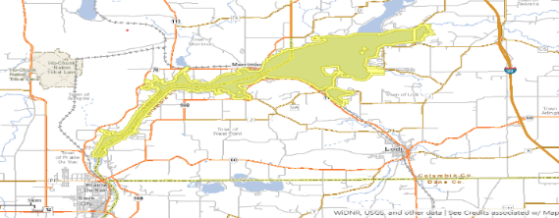
Lake Wisconsin Alliance invites you to Join us for the adventure of exploring our lake area and what it has to offer.
LWA Explore the watershed Calendar for 2024. 2 Remaining events
LWA series includes several 3-hour events through the summer and fall to increase awareness of our watershed area and activities.
Each event will include an education portion, time to explore or hike, and time to eat together and support our business members. Registration revskell2@gmail.com is encouraged. You may participate for the 3 hours or pick only part of each event.
September 21-Merrimac Preserve- S6888 WI-113, Merrimac, WI 53561—Lecture and history of preserve, Hike the ice age trail and View over 600 acres of Prairie. 9-12. Noon lunch- Eat at Lucky’s On The Lake, Bar and Grill. W11585 Co Rd V, Lodi, WI 53555. Jessica Renley, Executive Director of Riverland Conservancy: Merrimac Preserve, will give an orientation to the preserve and share the recent work to establish prairie acres. She will orient us to the 9 miles of trails and the scenic Ice Age Trail that meanders through the preserve. Our hike day will end with a lunch together at Lucky’s in Okee on the shores of Lake Wisconsin.
https://riverlandconservancy.org/merrimac/ for pictures

October 19 Gibraltar Rock Nature Area. Gibraltar Rock Rd, Lodi, WI 53555. 9-12 Talk and history. Hike the ice age trail and view the Fall Colors. Noon- Eat at Fitz’s on the lake. W11602 Co Rd V, Lodi, WI 53555. https://www.devilslakewisconsin.com/wisconsin-parks-trails-natural-areas/gibraltar-rock-state-natural-area/ for pictures.
Gibraltar Rock State Natural Area near Lodi offers some of the most spectacular vistas in the state. Gibraltar Rock State Natural Area is about is 68 acres in size and is located on the 1,000-mile-long Ice Age Trail. The Gibraltar bluff stands some 1,234 feet above sea level while it’s sheer 200 foot cliffs offer an amazing view of Wisconsin River valley. Miles of rolling hills and farmland spread out to the south and east while Lake Wisconsin and the Baraboo range provide a stunning backdrop to the north.

